SyncBox

Iteration Plan

Version <1.0>

Revision History

|  |  |  |  |
| --- | --- | --- | --- |
| **Date** | **Version** | **Description** | **Author** |
| 02/Jan/21 | 1.0 | Iteration plan | Altay Brusan |
|  |  |  |  |
|  |  |  |  |
|  |  |  |  |

Table of Contents

1. Introduction 4

1.1 Purpose 4

1.2 Scope 4

1.3 Definitions, Acronyms, and Abbreviations 4

1.4 References 4

1.5 Overview 4

2. Plan 4

3. Resources 6

4. Evaluation Criteria 6

Iteration Plan

# Introduction

This document materializes the road map and milestones of the SyncBox project

## Purpose

The aim of this document is to unify the team members understanding from the steps we planned toward the end of the project.

## Scope

The iteration plan is limited to SyncBox and limited to its circuit and firmware development.

## Definitions, Acronyms, and Abbreviations

SyncBox: Synchronization Box. A unified hardware platform for radiology scanner.

## References

F. A. Durmaz, A. Brusan and C. Ozturk, "Unified Open Hardware Platform for Digital X-Ray Devices; its Conceptual Model and First Implementation," in IEEE Journal of Translational Engineering in Health and Medicine, vol. 8, pp. 1-11, 2020, Art no. 1800311, doi: 10.1109/JTEHM.2020.3000011.

## Overview

In the following the iteration plan, including timelines, resources and budget are discussed.

# Plan

The hardware architecture is divided into two main units: microprocessor and microcontroller. The processor unit is responsible for high level and complex tasks which requires high processing capacities. The low level controlling and communication but not computation intensive tasks are done by a micro controller. To implement this architecture, the project is planned to be finished in three iterations.

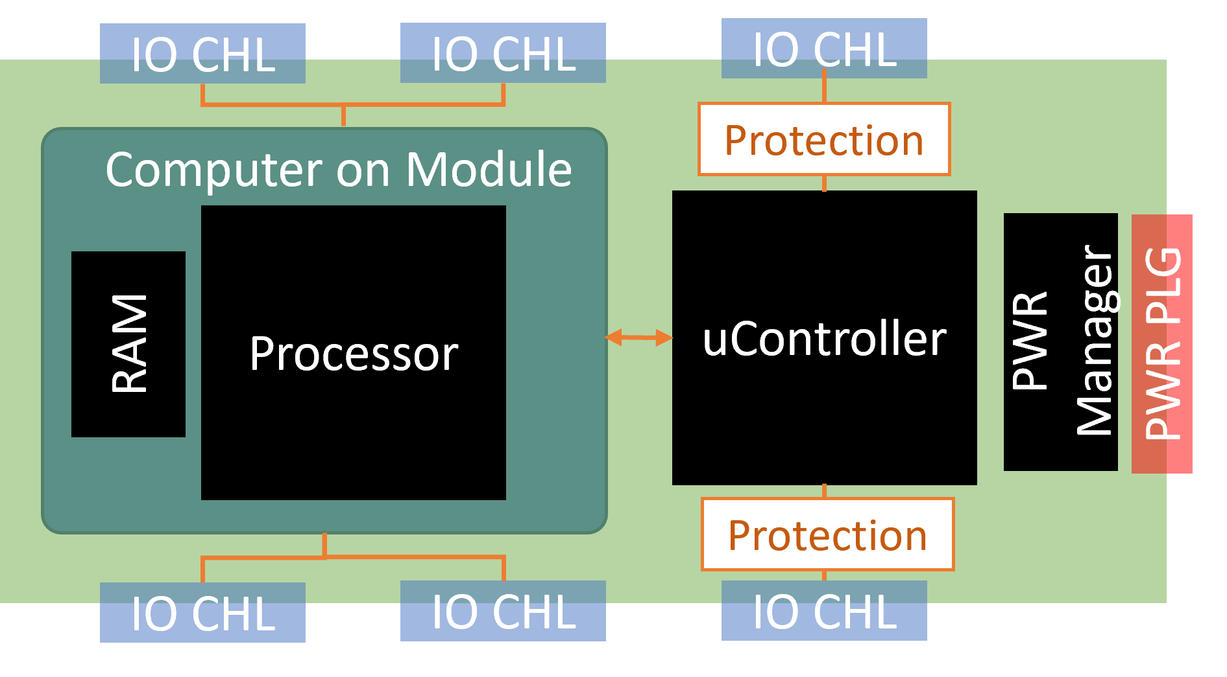

In the first iteration the microcontroller section is solidified. The first iteration is to develop the microcontroller architecture. In this iteration microcontroller circuit is developed and it provides the functionalities that it is targeted for: communication with power source, X-ray detector and mechanical units. The output of this iteration is a working microcontroller system. It could be implemented on proof board or on a PCB.

In the second iteration the processing unit architecture is decided. In this iteration i) Select the best fitted Computer on Module, ii) design and develop a board for the selected board, iii) integrate the board with the first iteration board. The output of this section is a high-level processing unit which can execute the high-level processing tasks. The deliverable of this iteration is an extension board with a computer-on-module on it.

In the third iteration two sections are brought together and tests and evaluation are done to resolve any potential problem. The deliverable of this iteration is debugged, tested, and evaluated fully function system which includes both CPU and microcontroller units.

|  |  |  |
| --- | --- | --- |
| Activity | Start Date | End date |
| Design and implement microcontroller board | 13 Jun 2021 | 12 Jul 2021 |
| Design implement CoM extension card | 14 Jul 2021 | 24 Sep 2021 |
| Design and implement complete board | 26 Sep 2021 | 28 Dec 2021 |

# Resources

For the first iteration:

* Staffing resources: two electronic engineers and two embedded software developer
* Financial resource: 6000 USD for component, in addition to payments and invoices
* Equipment and Facility: firmware development compiler, benchtop power source, oscilloscope, bill of materials used in circuit design.

For the second iteration:

* Staffing resources: two electronic engineers and one application developer
* Financial resource: 10000 USD for components, in addition to payments and invoices
* Equipment and Facility: firmware development compiler, benchtop power source, oscilloscope, spectrum analyzer, bill of materials used in circuit design.

For the third iteration:

* Staffing resources: three electronic engineer , two software engineers, a mechanical designer
* Financial resource: 15000 USD for components, in addition to payments and invoices
* Equipment and Facility: laboratory benchtop power source, oscilloscope, spectrum analyzer, bill of materials used in circuit design.

# Evaluation Criteria

The CE and EMC standards must be passed. Also, medical software grades compatibility is required.